

**Final Project**

**Department of Computer Science and Engineering**

Course Code: CSE 209

Section: 2

Course Title: Electrical Circuit.

**Submitted BY:**

Name: Ariful Islam Fardin

ID: 2020-1-60-111

Date of Report Submission:9 September 2021

**Submitted To:**

**Reshedul Amin Tuhin**

Senior Lecturer, Department of Computer Science and Engineering

**Tittle:** PSpice Analysis for Maximum Power Transfer.

**Q 1**. Using PSpice Simulation, determine the Thevenin’s equivalent of the circuit looking from

the load resistance RL .

**ANS:** the original circuit given on the question is

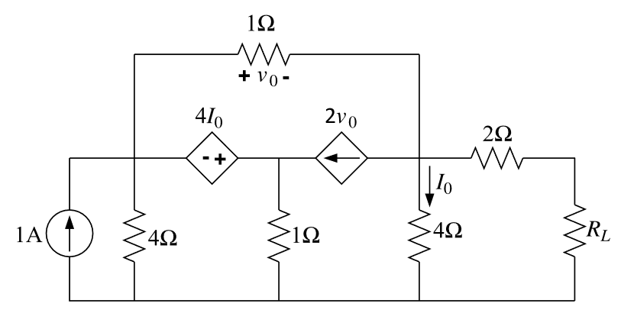

Figure :1

From the PSpice simulation we can see

**Figure 2**

From the figure 2 we find Voc=0.457V

**Figure 3**

From the figure 3 we find Isc= 242.42mA

Figure:4

Rth =RL= Voc/Isc

Rth =0.457/242.42m

Rth =1.88 Ω

**Q 2**. From the Thevenin’s equivalent circuit, theoretically determine the value of load resistance

R L for maximum power transfer. Using PSpice Simulation of the Thevenin’s equivalent

circuit with R L for maximum power transfer, determine the value of maximum power

transferred to R L?

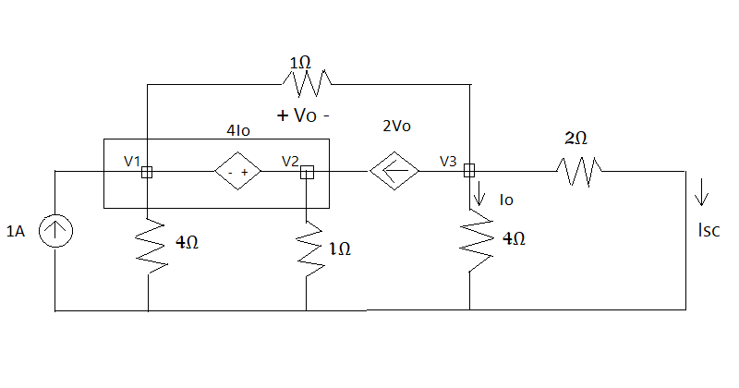

Figure 5

Applying KCL at Super Node,  
 -1+(V1/4)+(V1-V3)/1+(V2/1)-2(V1-V3)=0  
 or, -3/4 V1 + V2 + V3 = 1……..(1)   
Applying KCL at 3,  
 V3 - V1 + 2(V1 - V3 ) + V3 / 4 + V3 / 2 =0  
or, V1 – 1/4 V3 = 0……(2)

From the super node ,

V2-V1= 4I0 [I0=V3/4]  
 or,- V1 + V2 - V3 = 0……(3)  
After calculation from equation 1,2 and 3

V3 =0.48484V  
So, Isc = V3 /2

Isc = 0.4848/2

Isc =0.24242A

Now,

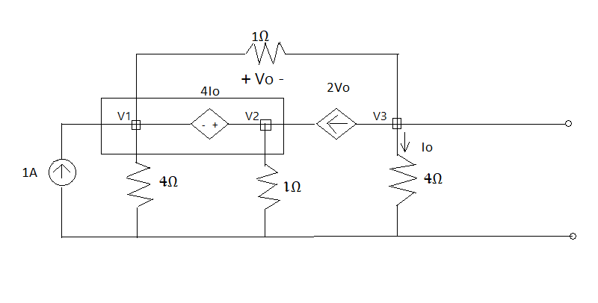

**Figure 6**

Applying **KCL** at super node respectively,  
 -1+(V1/4)+V1-V3+V2-2(V1-V3)=0  
or,(-3/4 V1)+V2+V3 =1………………..(1)  
Applying **KCL** at node 3 respectively,  
 V3-V1 +2(V1-V3)+ V3 /4 = 0  
or, V1 –( 3/4 V3 )= 0 ………………..…(2)  
From super node ,  
 V2 - V1 =4* V3 / 4  
or,- V1 + V2 - V3 = 0 …………………(3)  
From equation (1), (2) ,And (3)  
V3 = 16/35 =0.457V  
V3 = Voc =Vth= 0.457V

Rth =RL= Voc/Isc

Rth =0.457/0.24242

Rth =1.88 Ω

Pmax = Vth2 / 4Rth

Pmax =(0.457)2 /4*1.88

Pmax = 0.0277W

OR, Pmax = 0.0277W

So, Pmax = 0.028W

**Q 3**. Using PSpice Simulation with resistance sweep, determine the value of R L for maximum

power transfer and the corresponding maximum power.

Ans:

From the graph max power is 27.706mw =0.27706W.

**Q4.** Compare the value of R L and maximum power obtained in steps 2 and 3.

|  |  |  |
| --- | --- | --- |
|  | **STEP 2** | **STEP 3** |
| **RL** | 1.88 Ω | 1.88 Ω |
| **Pmax** | 0.028W | 0.0277W  =0.028W |

**ANS:**  from the table we can see there is no difference between theoretically calculation and PSpice simulation